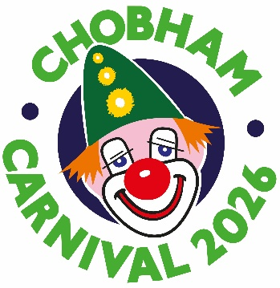

2026 CARNIVAL BALL TICKET APPLICATION
Chobham Village Hall – Saturday May 2rd

Name
Address
Telephone Number
Email
Please reserve me ………………tickets for the ball at £50 each.

My total payment is: £………. Payment by online funds transfer is preferred. Cheques are also acceptable and should be made out to Chobham Carnival Association.
I enclose a cheque (tick) ………
I am paying online (tick) ………….
Please add a reference: Ball & your Surname – Sort code 20.90 56, Account 90255092, Chobham Carnival Association

On the day:
• Dress code: “black tie”.
• Ticket price covers: Canapes, a two-course meal with coffee. There is a live band and a beer, wine and soft drinks bar.
- Paper tickets will not be issued but an acknowledgement will be sent by email.
• Doors open at 6pm, canapes are served from 6.30pm
• There will be a raffle and a silent auction of donated items, proceeds to the carnival’s good causes fund.
• We will endeavour to seat groups of friends together on the same table – based on the surname of the person who books.

Send this form with payment BEFORE APRIL 17th (EMAIL PREFERRED) to: chobhamcarnivaltreasurer@gmail.com
or post to:
Chobham Carnival Ball Tickets, c/o The White House, Guildford Road, Chobham, Surrey GU24 8EA

Enquiries to the above email or by phone to 07835 198845

