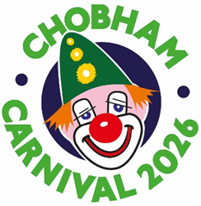
PROGRAMME COMPETITION ENTRY FORM
Theme: THE WORLD OF CHILDREN’S STORY CHARACTERS
We need the help of children aged 12 and under to design the front page of the programme for this year’s carnival, which is on Monday 4th May. There is a prize of £25 for the winning entry, plus £25 for your school
Simply draw a colourful picture to fit the box below illustrating the theme of The World of Children’s Story Characters. You can choose what to draw – there are plenty of ideas connected with the theme.
Then fill in this form, or ask a parent or guardian to do it, and either send it to the address below or scan the form as a high-resolution JPEG or PNG file and send it by email. A parent or guardian must give permission, below, for the picture to be printed on the front of the programme if it wins the competition, along with the winner’s first name, age and school.
Entries must be received by Wednesday 11th March and the winner will be notified soon after that date.
Name: ………………………………………………………………………………….. Age: ……………………………
School: ………………………………………………………………………………………………………………………..
Home address: ………………………………………………………………………………………………………………. ……………………………………………………………………………………………………………………………………
Parent or Guardian’s name and signature: ………………………………………………………………………………
Contact email and phone number: ………………………………………………………………………………………..
Idea for next year’s theme: .....................................................................................................................................

SEND TO:
Email: chobhamcarnivaltreasurer@gmail.com
Post: Chobham Carnival Programme, c/o The White House, Guildford Road, Chobham, Surrey GU24 8EA
Telephone inquiries: 07835 198845 (Orla)

