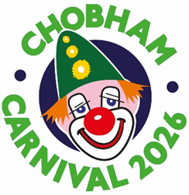
Carnival Queen and King Entry Form 2026
How would you like to be famous for a day?

If you are a girl or a boy in school years 2 to 6, you have the opportunity to be our Carnival Queen or Carnival King on Monday May 4th 2026 at the Chobham Carnival!

Print this form, fill in all the information and, on page 2, draw a picture of yourself and feel free to give us an idea for next year’s theme!
Then ask a parent or guardian to sign the form and send it to the address below.
Name: | Age:
Address:

School: | Contact phone number:
Hobbies/Sports/Interests:

Entries must be received by Friday 27th March 2026. The judges’ decision is final and the successful applicants will be contacted by phone on or around April 17th.
Outfits will be provided (except shoes), and details and times of the event will be discussed at the time of notification.
THIS APPLICATION MUST BE AUTHORISED BELOW BY A PARENT OR GUARDIAN:
I am happy for my daughter/son to take part in the Chobham Carnival Queen/King competition and will ensure that he/she will be available from 9am on Monday 4th May, to take part in the procession, if they are a winner.
Name of authorising parent/guardian:

_______________________________________________________________________

Signature of authorising parent/guardian:

_______________________________________________________________________

SEND TO:
Email: chobhamcarnivaltreasurer@gmail.com
Post: Chobham Carnival King & Queen, c/o The White House, Guildford Road, Chobham, Surrey GU24 8EA
Telephone inquiries: 07835 198845 (Orla)

Draw a picture of yourself here and then tell us about your idea for the 2027
carnival theme

My idea for the 2027 carnival is:
________________________________________________________________________
________________________________________________________________________

