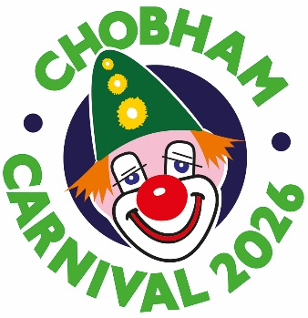

STALLHOLDERS APPLICATION
For Monday, May 4th, 2026

Name of organisation or business
Contact name
Contact address
Contact Telephone Number
Email
Required stall size (state width of gazebos/tents/marquees/tables)
Purpose of the Stall (food/craft/entertainment etc)
Preferred location (this cannot be guaranteed)

STALL CHARGES:

Charities, Clubs and Community Organisations: £30 up to 2.5 metre pitch; 3 metre pitch £35; 4 metre pitch £40.

All traders: By negotiation. Before submitting a form please email chobhamcarnivalstalls@gmail.com with your requirements and, if applicable, the fee you paid last year.

My total payment is: £…….…. Payment by BACS is preferred. Cheques should be made out to Chobham Carnival Association.
I am paying by BACS (tick)………
Reference “Carnival Stall + Your Name” – Sort code 20.90 56 – Account 90255092
N.B. I am providing a copy of my organisation’s/business’s public liability insurance (tick)……
I am selling food and providing a copy of my food hygiene certificate (tick)……
I am providing my LPG gas safety certificate (tick)……

ON CARNIVAL DAY:
• Stalls must be set up between 8am and 10.30am
• Stalls can open between 11am and 5pm
• Stalls must be dismantled and removed from the recreation ground by 6pm
You will receive arrival instructions giving your stall location a few days before the event.
Please ensure that your tables, gazebos and displays fit within your pitch, as no extra room is available on the day.
Stallholders MUST CLEAR THEIR PITCH OF LITTER and their own rubbish and take it away. DO NOT USE THE RUBBISH BINS provided for public use, as this is likely to exclude you from future participation at the carnival.
YOU MUST ASK PERMISSION to keep a vehicle by your pitch between 10.30am and 5pm.

Send this form by email (PREFERRED) to: chobhamcarnivalstalls@gmail.com
Or post to: Chobham Carnival Stall Application, Farrs, Clappers Lane, Chobham, Woking, Surrey GU24 8DD.
Enquiries to the above email or by phone to 07485 230523
Unless informed otherwise, we assume that you agree to the carnival association keeping your email and other details on file.

